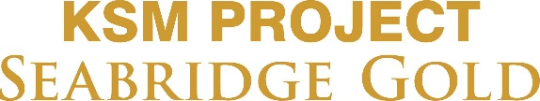

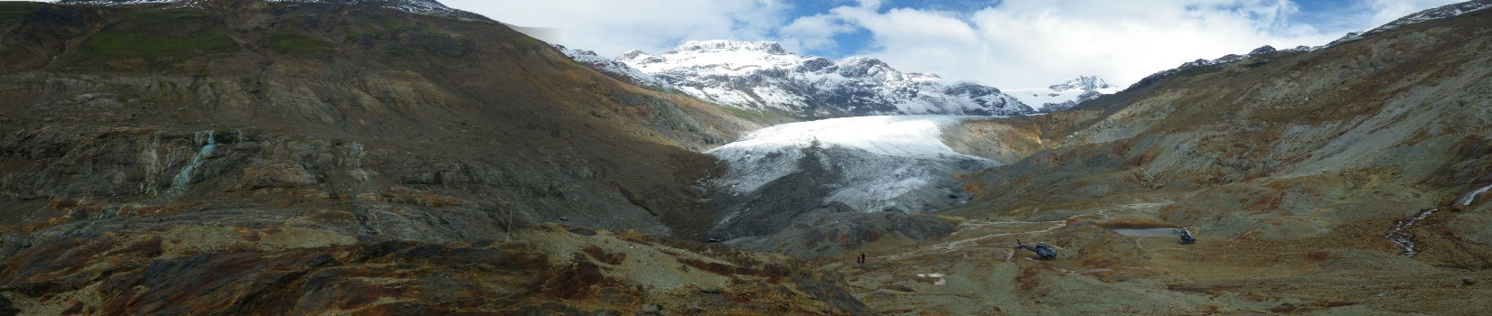
The 2017 Seabridge Gold –KSM Project Winter Bursary Application
Seabridge Gold owns the KSM Project, a proposed gold, copper, silver and molybdenum mine, located 65 northwest of Stewart, BC. The KSM Project will employ approximately 1,800 people during its 5-year construction and approximately 1,040 jobs during its 52-year mine life. While construction has not yet started on the KSM Project, Seabridge Gold supports building a strong workforce in northwest BC and finds value in supporting local residents to further education and training. As a result, Seabridge Gold is implementing a 2017 bursary program to support students from northwest British Columbia (BC) access education and training.
If you are a resident of northwest BC (defined as west of Burns Lake north to the Yukon border), are currently enrolled in studies, and are interested in applying for this bursary please read and complete the following application. Applicants must complete all seven sections, and provide the specified documentation such as proof of enrollment, support letters among others. Each section of the application will be reviewed and scored, the successful recipients will be notified approximately two weeks following the submission deadline. This is the winter round for the bursary program and is open to students currently enrolled in studies for the winter semester (Jan – April 2017) and will be announced March 24, 2017.
Submission Deadline: March 8, 2017 Results Announced: March 24, 2017

Name: ______________________________________________________
First Last
Contact
Information: ___________________________________________________________
Mailing Address: City: Province: Postal Code:

___________________________________________________________
Phone: E-Mail Address:

Canadian Citizen: (Circle one) Yes No
Northwest BC Hometown: (please specify) __________________
Age: (Circle one) 18-25 26- 35 36-46 Mature Student
I self-identify as belonging to a Treaty or First Nation (please specify) ____________________
- Bursary Applied For (select one only):
☐ Academic Bursary Award (University courses)
☐ Non-Academic Bursary Award (Trades, Non-Academic courses, Up-Grading)

- Please provide current enrollment information including University, College or Education Institution.
Student #:___________________________
Post-Secondary Institution | Program/Degree Name | From  Year Month | To  Year Month

- Please provide most recent transcripts.
☐ Transcripts included (check to confirm you have attached this information)

- Please provide proof of enrollment to verify enrollment for January 2017 term.
☐ Enrollment confirmation attached (check to confirm you have attached this information) ie: acceptance letter

- Please provide an essay description outlining the following areas.

- Describe in detail how you are involved in your community – either long term volunteer contributions or short time volunteer projects, include roles, responsibilities, length of time contributed to volunteer groups or projects? Minimum 150 words, please attach additional pages if needed.

- What are your education objectives? Minimum 150 words, please attach additional pages if needed.

- What are your career objectives and how will your career benefit the mining industry? Minimum 150 words, please attach additional pages if needed.

- Please select a bursary amount; $500, $1000, or $2000, and describe what the funds will be used towards. ie –course fees, tuitions, student loans, books: Minimum 150 words, please attach additional pages if needed.

- Letters of Support: Please include reference letters from instructors, teachers, employers, organization representatives, volunteer groups or other applicable organizations, as an attachment to this application (Minimum 1).

☐ Letter (s) of support included (check to confirm you have attached this information)

- Declaration:

Acceptance of Terms:
I confirm that I am applying to the Seabridge Gold –KSM Bursary Program, and certify that the information I have provided in this application is true and complete.

I authorize Seabridge Gold to verify the information contained in this application, and in any supporting documentation I have supplied with (1) relevant post-secondary educational institution (s) within and outside of British Columbia. I further consent to the release of information from those sources that may be approached by Seabridge Gold to verify the information I have provided.

Signature of Applicant | Print Name | Date: Year/ Month/ Day

Bursary Promotion:
Seabridge Gold would like direction with respect to the publishing of your name, hometown, and education institution for the purpose of promoting the bursary program and its results.
☐ Yes, Seabridge Gold may publish my name, hometown, and educational institution(s) attended in connection with any bursary I might receive.

* Applications, essay and additional attachments will only be accepted via scan and e-mail submitted to ksm_community@seabridgegold.net by March 8, 2017.
* For enquiries and addition questions contact Seabridge Gold at (250) 847-4704
or ksm_community@seabridgegold.net

For Office Use Only (Applicant is not required to do anything for this section)
Date:
Name:
Total Score:

