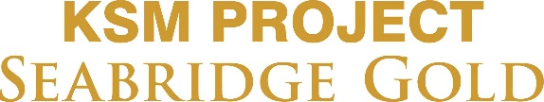

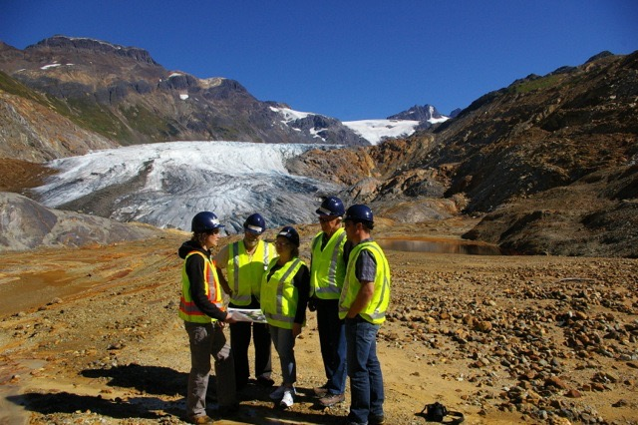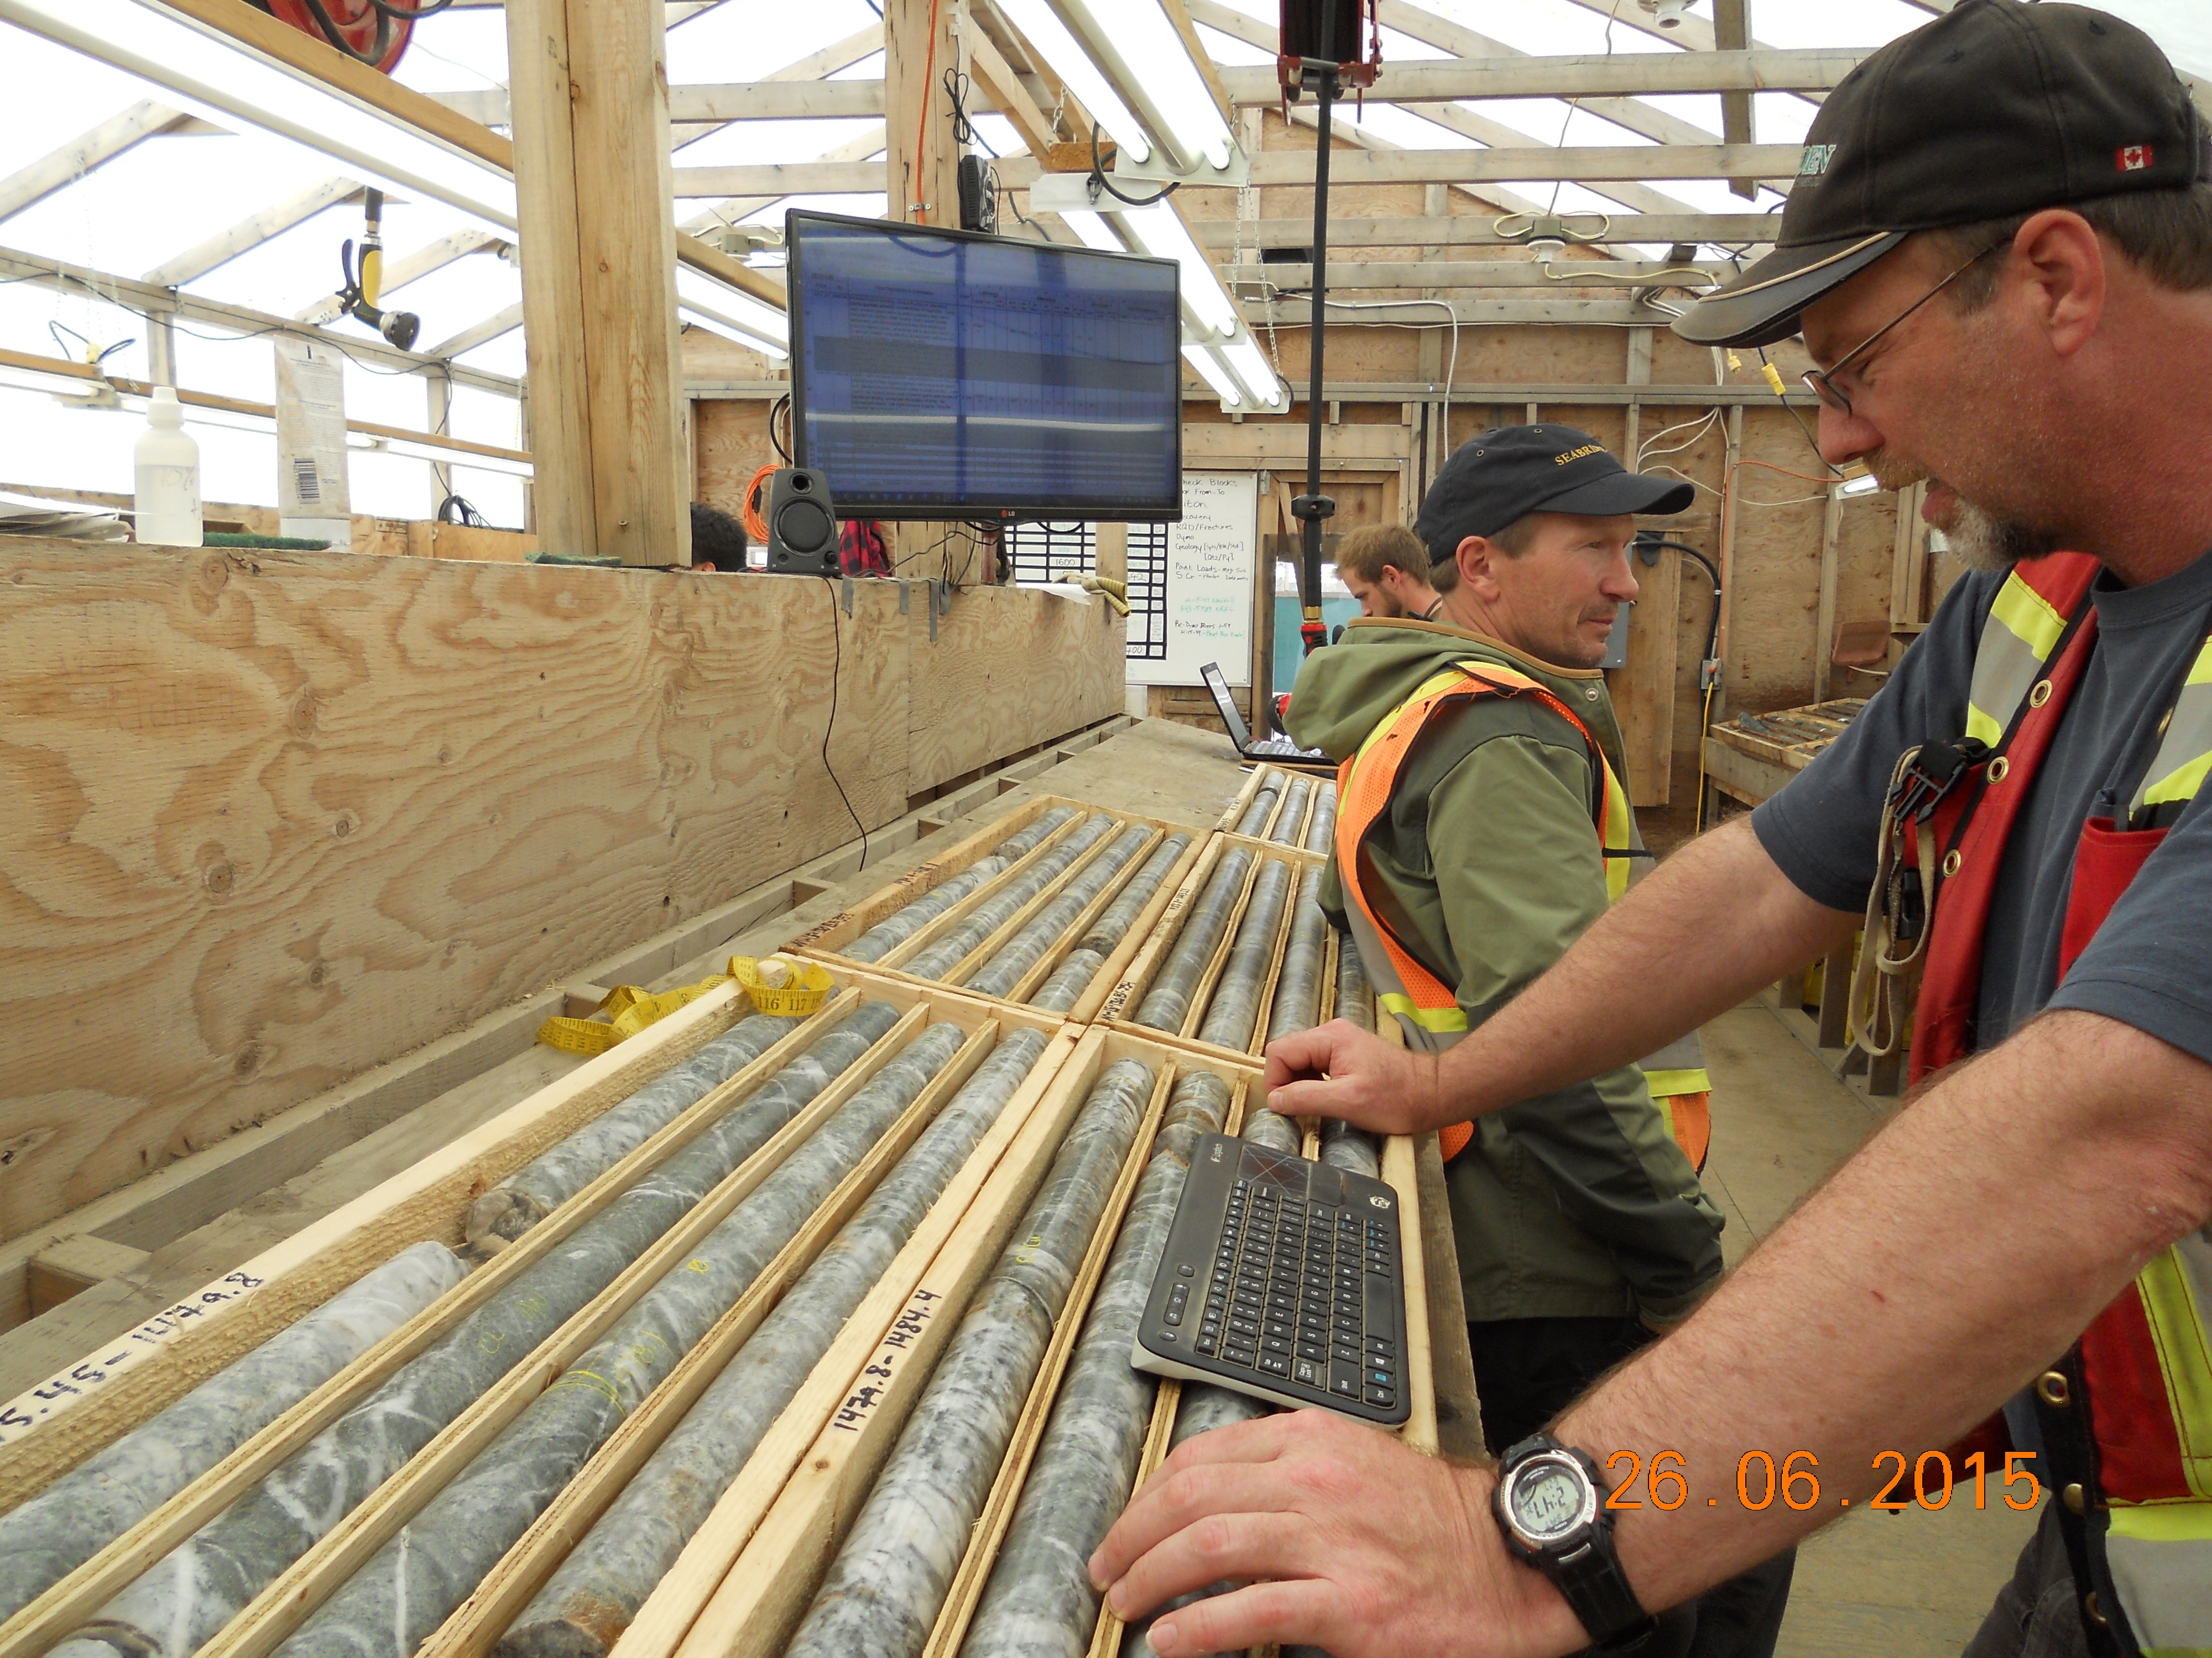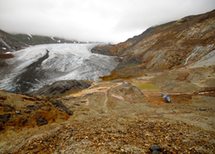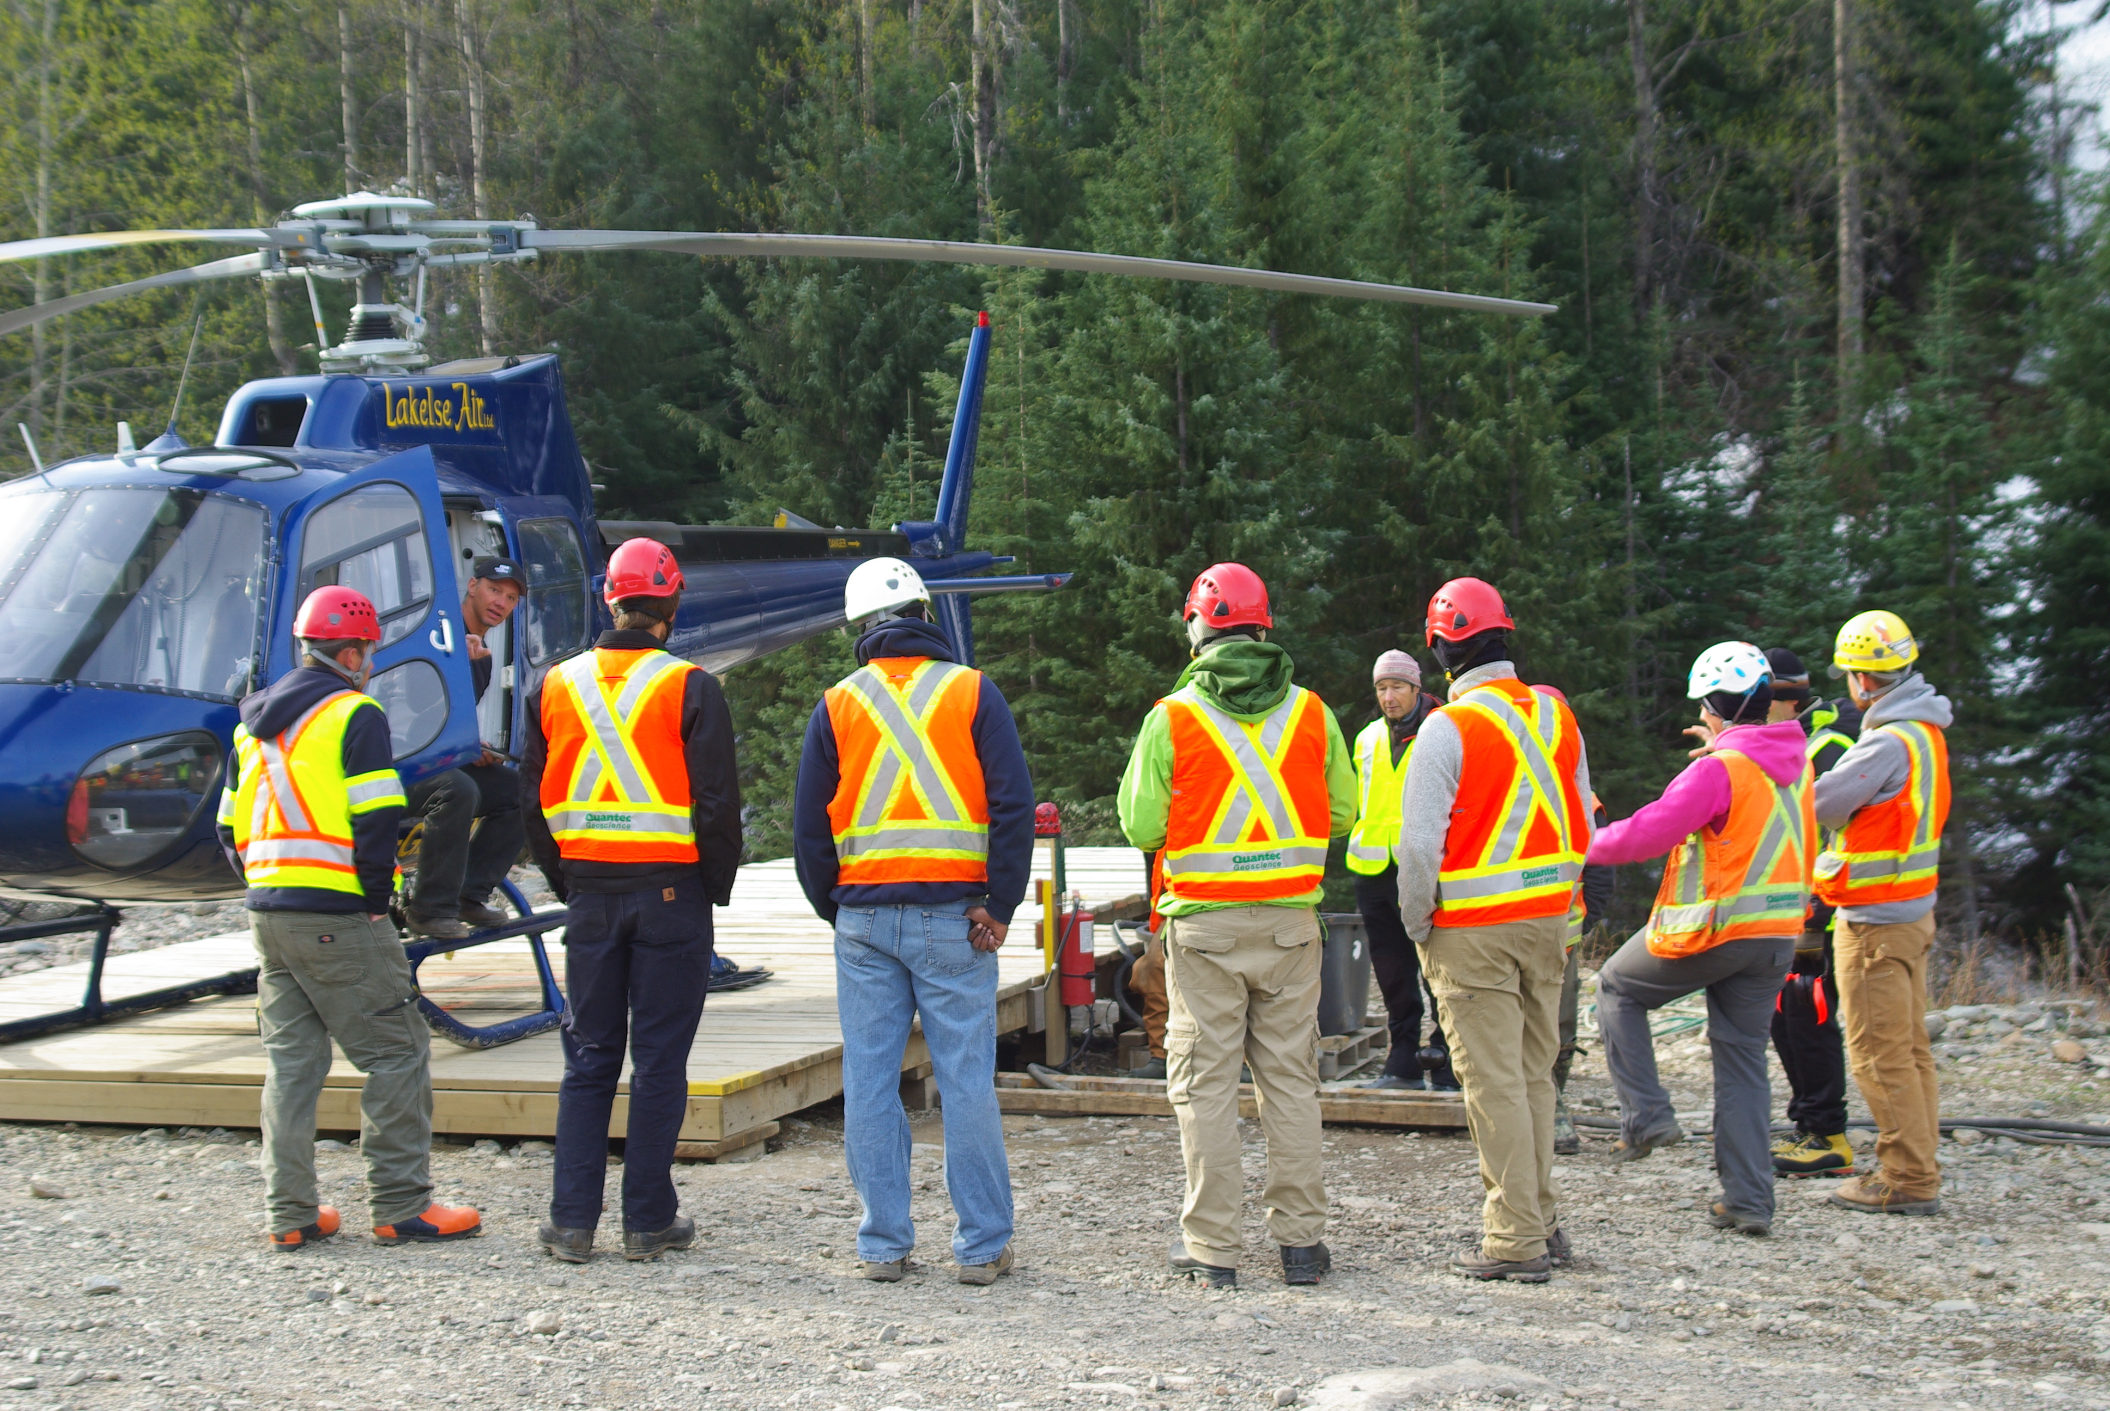
The 2019 Seabridge Gold –KSM Project Fall Bursary Application
Seabridge Gold owns the KSM Project, a proposed gold, copper, silver and molybdenum mine, located 65 kilometers north of Stewart, BC. The KSM Project will employ approximately 1,800 people during its 5-year construction phase and approximately 1,040 jobs through the forecasted 52-year mine life. While construction has not yet started on the KSM Project, Seabridge Gold supports building a strong workforce in northwest BC and finds value in supporting residents to further their education and training. As a result, Seabridge Gold has implemented the 2019 bursary program to support students from northwest British Columbia (BC) access education and training.
If you are a resident of northwest BC (defined as west of Burns Lake north to the Yukon border), currently enrolled in studies, complete the following application for an opportunity to receive financial support towards your education. Applications will be reviewed and scored, based on the completion of the six sections and submission of the required documents. This is the fall round for the bursary program and is open to students enrolled in studies for the fall semester (September - December 2019) and will be announced on September 3, 2019.
Submission Deadline: August 12, 2019 Results Announced: September 3, 2019

Name: ______________________________________________________
First Last
Contact
Information: ___________________________________________________________
Mailing Address: City: Province: Postal Code:

___________________________________________________________
Phone: E-Mail Address:

Canadian Citizen: (Circle one) Yes No
Northwest BC Hometown: (please specify) __________________
Age: (Circle one) 18-25 26- 35 36-46 Mature Student
I self-identify as belonging to a Treaty or First Nation (please specify) ____________________

1. Bursary Applied For (select one only):
☐ Academic Bursary Award (University courses)
☐ Non-Academic Bursary Award (Trades, Non-Academic courses, Up-Grading)

- Please provide current enrollment information including University, College or Education Institution.
Student #:___________________________
Post-Secondary Institution | Program/Degree Name | From  Year Month | To  Year Month

- Please provide most recent transcripts. Official transcript not required, but name/ institution must clearly be identified.
☐ Transcripts included (check to confirm you have attached this information)

- Please provide proof of enrollment to verify enrollment for January-April 2019 term.
☐ Enrollment confirmation attached (check to confirm you have attached this information) ie: acceptance letter, or course enrollment schedule etc.

- Please provide an essay description outlining the following areas.

- What are your education and career objectives? How will your career benefit the mining industry? 50-150 Words

- Describe in detail how you are involved in your community – either long term volunteer contributions or short time volunteer projects, include roles, responsibilities, specific length of time contributed to volunteer groups or projects? 50-100 Words

- Letters of Support: Please include a reference letter. This could be from instructors, teachers, employers, organization representatives, volunteer groups or other applicable organizations, attach to this application (Minimum of one support letter and letters are to be dated within the last 12 months).

☐ Letter (s) of support included (check to confirm you have attached this information)

- Declaration:

Acceptance of Terms:
I confirm that I am applying to the Seabridge Gold –KSM Bursary Program, and certify that the information I have provided in this application is true and complete.

I authorize Seabridge Gold to verify the information contained in this application, and in any supporting documentation I have supplied with (1) relevant post-secondary educational institution(s) within and outside of British Columbia. I further consent to the release of information from those sources that may be approached by Seabridge Gold to verify the information I have provided.

Signature of Applicant | Print Name | Date: Year/ Month/ Day

Bursary Promotion:
Seabridge Gold would like direction with respect to the publishing of your name, hometown, and education institution for the purpose of promoting the bursary program and its results.
☐ Yes, Seabridge Gold may publish my name, hometown, and educational institution(s) attended in connection with any bursary I might receive.
□ No, Seabridge Gold may not publish my name, hometown, and educational Institution (s) attended in connection with any bursary I might receive.

* Applications, essay and additional attachments will only be accepted via scan and/or e-mail submitted to ksm_community@seabridgegold.net by August 12, 2019.

* For enquiries and additional questions contact Seabridge Gold at (250) 847-4704, ksm_community@seabridgegold.net

